**Air Force Research Laboratory’s (AFRL) Center for Rapid Innovation (CRI)**

**2019 University Design Challenge (UDC) and Service Academy Challenge (SAC)**

**Problem Statement: *Mobile Active Threat Emergency System (MATES)***

This Senior Capstone Design project during the UDC/SAC is to perform in-depth research, consultation, and exploration to engineer, design, and build a prototype system to locate personnel during an Active Threat (shooting, stabbing, bomb, hostage taking) event in an educational, office, shopping, or multi-room facility and integrate data streams (information coming to the command center) to provide First Responders with real-time info. It is assumed a threat causes personnel to “shelter-in-place” and often these personnel are unable to receive or send communications and unaware if the threat is active, contained, or eliminated; injured or captive personnel may be unable to communicate with outside, rescue, or other personnel; and finally, integrate information from on-site, radio, telephone, and miscellaneous data sources into a usable First Responder tool.

According to the Federal Bureau of Investigation (FBI), there were 250 Active Shooter incidents in the United States from 2000-2017. Of these 250 incidents, 52 of them or 20.8% were at Educational Institutions. According to the FBI, an “active shooter is an individual actively engaged in killing or attempting to kill people in a populated area.” The United States Department of Homeland Security defines an active shooter as "an individual actively engaged in killing or attempting to kill people in a confined and populated area; in most cases, active shooters use firearms, and there is no pattern or method to their selection of victims. Most incidents occur at locations in which the killers find little impediment in pressing their attack. Locations are generally described as soft targets, that is, they carry limited security measures to protect members of the public."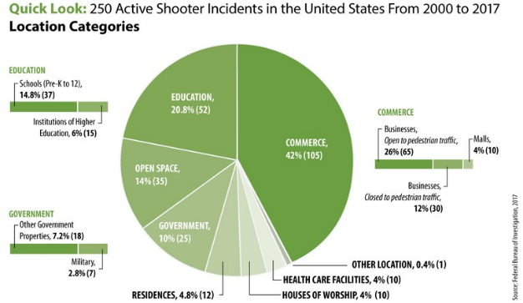

Figure 1: *The above pie chart shows a statistical breakdown of the location categories where the 250 active shooter incidents took place in the U.S. from 2000 to 2017. Those location categories include: areas of commerce, 105 incidents or 42 percent; educational environments, 52 incidents or 21 percent; government property, 25 incidents or 10 percent; open spaces, 35 incidents or 14 percent; residences, 12 incidents or 5 percent; houses of worship, ten incidents or 4 percent; and health care facilities, ten incidents or 4 percent. https://www.fbi.gov/about/partnerships/office-of-partner-engagement/active-shooter-incidents-graphics*

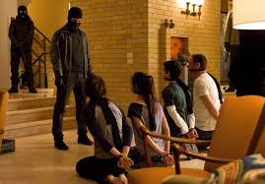Due to the rapid and dynamic nature of active threats and their propensity to occur against soft targets and unarmed persons, First Responders must be trained and prepared to address these incidents by recognizing characteristics associated with past attackers, maintaining situational awareness, developing countermeasures, and integrate all methods of communication sources for immediate use. Additionally, First Responders must determine which personnel are hostages and which is the threat(s), as well as, who requires medical care and specialized extrication.

In any situation, the “operator” (military, police, first responder) wants a device which works as advertised, has a small SWAP (size, weight, and power requirement), requires little to no training, and is easy to use. Consider flexibility of uses, the durability of the device, weather conditions, portability and probability of use over other methods.

Your team is required to meet and interview at least five Subject Matter Experts (SMEs) from different departments, groups, or areas. For instance, interviewing five campus police officers does not count. Consider police, military, first responders, security guards, school resource officers, and so forth. Bonus points for interviewing personnel involved with a real active threat or active shooter incident or a professional trained to teach and instruct active shooter events. Additionally, concept drawings are required during your PDR telecons and photographs are required during your CDR telecon and video proof of your device during testing is required in your in-person briefing to the judges. Your final design must be operational and undergo at least one test prior to attending the event.

The University Design Challenge culminates in a Concept of Design briefing and Ground Demonstration of the student designs. The final demonstration includes three phases, conducted in sequence. First, present a thorough and in-depth presentation to the judges and SMEs in attendance. This briefing includes your research, reasoning, and engineering. Second, deploy your device into a “normal building environment ” and determine which rooms, offices, closets, and so forth have humans either hiding or captive, and attempt to determine which of any of the personnel are the active threat. Third, perform a similar search as above, however, in an outdoor environment through collapsed building material (such after an explosion), sand, dirt, tunnels, caves, vehicles, trailers, and so forth.

Scoring your Locator Device is based on Size, Weight, Performance, Ease of Operation, Reusability, Innovation, Creativity, Engineering, Research, SME interviews, Participation, Presentation, and Judge’s Comments.

If successful, your device may be included in your University or Military Academy’s First Responder Tactics, Techniques, and Procedures (TTPs). Your device may save the lives of your classmates, professors, administrators, and others at your school. Quite possibly, your system may be implemented in institutions, business, government, and commerce building across the world.

Program Manager, Mr. Mike Lazalier, [michael.lazalier.1@us.af.mil](mailto:michael.lazalier.1@us.af.mil), Arnold Engineering Dev Complex

Asst. Program Manager, Mr. Mickey Wright, [wrightm@rallypointmanagement.com](mailto:wrightm@rallypointmanagement.com), Rally Point Management